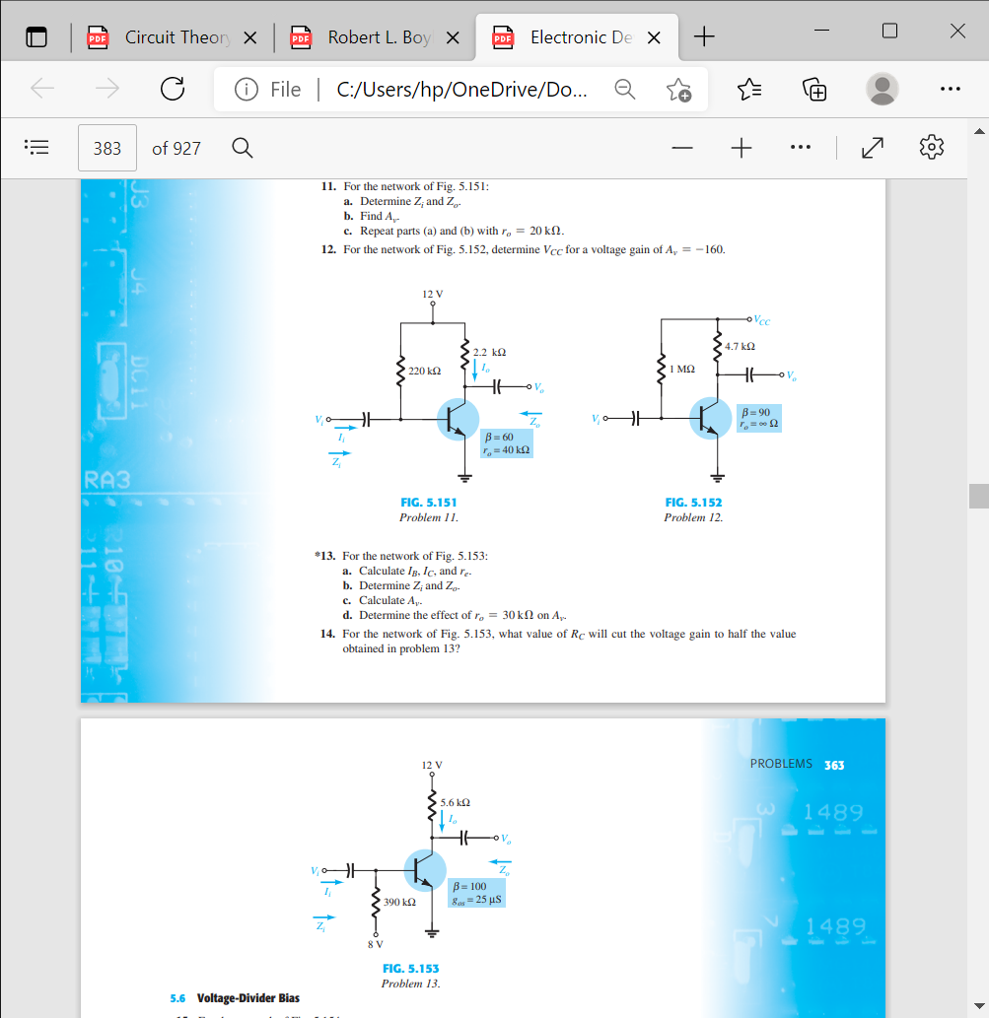
11. For the network of Fig. 5.151 :
a. Determine Zi and Zo .
b. Find Av .
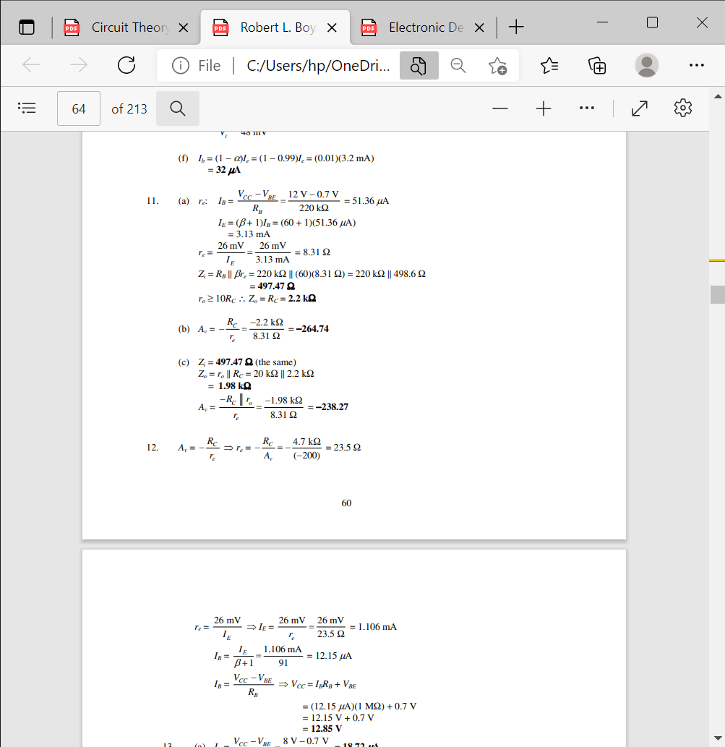
c. Repeat parts (a) and (b) with ro = 20 kΩ.
Jawab :

12. For the network of Fig. 5.152 , determine VCC for a voltage gain of Av = -160.

Jawab :

13. For the network of Fig. 5.153 :
a. Calculate IB, IC , and re .
b. Determine Zi and Zo .
c. Calculate Av .
d. Determine the effect of ro = 30 kΩ on Av .

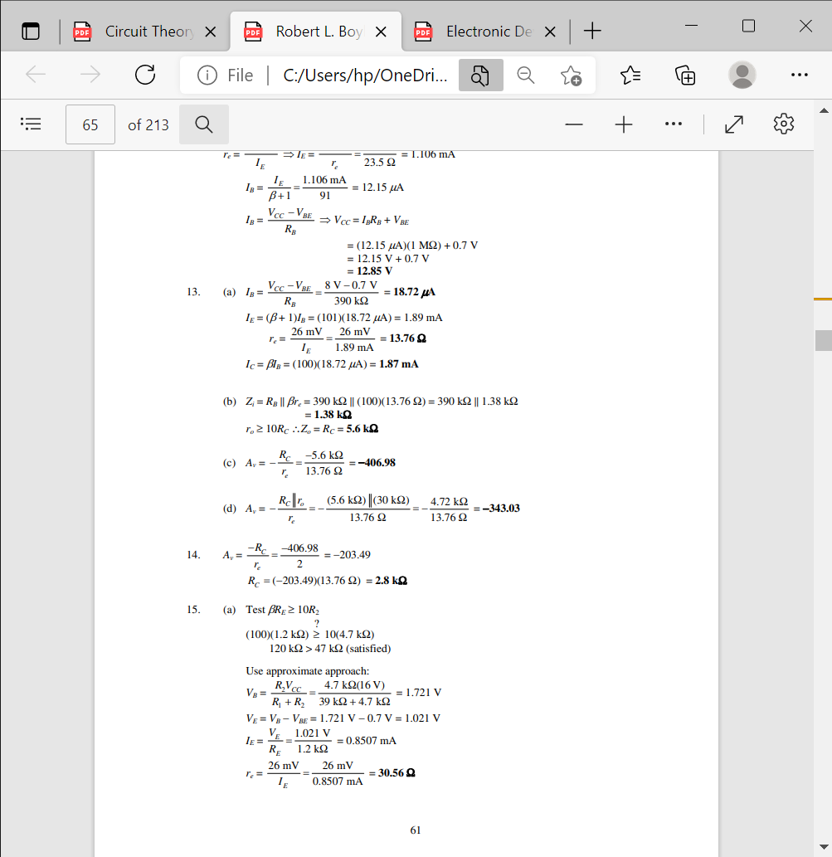
Jawab :

14. For r the network of Fig. 5.153 , what value of RC will cut the voltage gain to half the value
obtaine
Jawab :

